ASSESSMENT TEST WINTER SEMESTER
YEAR __________ Group no: ___ ______
NAME:__________________________; Album no: ________ Date: ___________

Student’s Book: The Business Upper-intermediate , unit: 1, 2 Score: ____________/ 60 marks

Listening (6 points)
Listen to a presentation of the business school, and complete the following sentences:

- Magnalia competes now in ……………………………………………, with giants such as Harvard and the London School of business.
- The school has a choice either to……….. ………… or to ………. ………., invest or develop new ways. .
- They have chosen to draw up …….. ………. ………. ……… to make this school truly international.
- The USPs are the …………… ……………… …..….. .
- The competitive advantage will help to attract the ……… ………… and the most ………… ……… ……….…..…. .
- Thanks to Ion Bumbescue’ s sponsorship, the school will …… ……… …… .

READING (4points)

Read the article on job interviews and sentences below.

For each sentence mark one letter (A, B, C or D).

It makes sense to interview no more than six candidates because of the cost and time involved. After the short-listing process of reviewing CVs or application forms against the job description and person specifications, preparation for the interviews can be started.
The aim of the interview is to collect information about the suitability of the candidate for a particular post, not to find out if the candidate is likeable. Individual interviews can be useful, but panel interviews can help protect against individual bias, though they are more expensive. Too many people on the panel can be intimidating: three seems to be a good number, with one chairperson. The interviewers should review the job description, person specification and applications, and be familiar with the requirements of the job. They should make notes of the key areas and discuss these with their colleagues. It should be clear before the interviews start who will ask which questions, because a free-for-all can be confusing for the candidate.
The interview should have a clear structure and this should be explained to the candidate at the very start. The chairperson should link between the phases of the interview and between the panelists. This is especially true for telephone interviews.
There are five phases to the interview. An introduction to the interviewers helps to settle the candidate. Then the structure of the interview should be explained.
The main phase is the questioning of the candidate to obtain the information necessary to make a good decision. Questions should focus on the past, not the future and the panel should avoid hypothetical questions. General questions should lead to more focused questions which are looking for evidence of what the candidate did in certain situations. You will use the CV or application form as the basis for this stage. You are looking for concrete answers which highlight learning experiences and achievements. You should also explore the candidate's background, expertise, knowledge and skills as well as what they think of as their strengths and weaknesses. You are also checking to see if there are any inconsistencies between what the application and the candidate says.
After this, the longest phase, the candidate should be invited to ask any questions they have about the job, the company, or anything else they might want clarified. Remember that the interview is not just about whether you feel the candidate is right for the job: it is also the time for the candidate to decide if the job and the company are suitable for them, and the opportunity for the candidate to question you is essential for them to be able to make this decision. At the conclusion of the interview the chairperson should make it clear when the candidate will hear the results of the interview.
An interview should be relaxed and friendly, but the interviewers should remain in control and be able to draw out nervous or shy candidates and to manage over-confident ones. Making a recruitment error can be very expensive and difficult to correct and interviewing should be seen as a moment of truth in the selection process.

1 In the second paragraph, the writer suggests there should be
A a large panel of good interviewers.
B four on a panel including one chairperson.
C a good number of people on the panel.
D a chairperson and two others on the panel.

2 The questioning phase of the interview is
A when the candidate can ask questions about the company.
B the longest and most important part of the whole interview.
C a time to talk about the past and future of the candidate.
D when you can ask what the candidate would do in certain situations.

3 According to the text the candidate can ask questions
A about what they have forgotten to say in the interview.
B to find out more about the interview.
C to find out when the results will be known.
D to help them decide if they are a good match for the job.

4 Which of the following best summarizes the text?
A An interview takes a long time.
B Interviews should be the same for everyone.
C Interviews are too important to get wrong.
D There are lots of documents for interviews.

LEXIS (10)
Complete the sentences with the synonymous expression:
- People who apply for a job are called __________
- If you are laid off, you are ________________
- If you give in your notice, it means you ___________________
- If you are currently enjoying having no work, you are ____________
- If you are making a positive career move in your company, it means you are _________

Correct the phrases in bold as they are used in the wrong places:
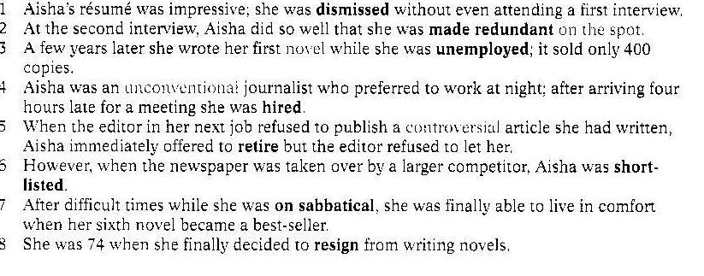

Choose from the list of words below to complete the text. You will not need all the words.

It is with regret that I have to tell you we are far from satisfied with the after-sales service and support we have received from your company. Our company is small, with no in-house IT department, so we rely on you to maintain our computing systems.

Since asking you to (1) _________ our operating system we have had nothing but problems. Our entire system keeps on (2) ________ because of incompatible software applications provided by you. This causes serious delays as our staff can do little when the whole system (3) ________ . Despite your firewall protection, a serious (4) _______ has entered the network, causing enormous damage, and several important documents have been (5) _________ , which has had severe financial implications for us.

Our original plans were to purchase further hardware from you to help mobilize our workforce, such as (6) ________ , and to (7) _________ a wireless connection through your company, but in light of our experiences we do not intend to proceed with this until you can demonstrate a great improvement in your services.

hard-disc failure ▪ server ▪ upgrade ▪ advance ▪ fall down
set up ▪ bug ▪ application ▪ deleted ▪ install PCs ▪ crashing ▪ virus ▪ goes down ▪ palmtops

Grammar 10 points
A
Your manager has given you the following information to help you decide which laptop to upgrade to. You are often on the move, and need constant access to your computer. Make a suggestion as to which one would be best for you. Write 3 sentences using the following phrases: a bit more …. , marginally less ……, somewhat more …., as …as, as many as , far more.

Make | ICM | Bandai | Phony
Price | $790.00 | $959.99 | $999.00
Memory | 768 MB | 1 GB | 1 GB
Display | 7 inch | 7 inch touch screen | 7 inch touch screen
Size | 225/165/35 mm | 23 x 13 x 2.8 cm | 227/114/25 mm
Weight | 920g | 830g | 825 g
USB Ports | 3 | 3 | 2
Battery life | Up to 4 hours | 2 hours | 2 hours 10 minutes

B
Complete the following sentences:
- The more I study, ………………………………….
- ………………………… , the more motivated I am.
C
Change the direct questions into indirect ones:
- When does the conference start? I would ………………………………………………………….
- Will you be attending the afternoon session? Could you tell me ………………………………………………………….
D
Insert the right form of verbs:
- Do you think it _________ (rain) soon?
- What salary ____ he_____ (get) if he lived in New York?
- The phone ___________ (ring) for ages before you answered it.

Jolanta Regucka-Pawlina

KEY
Listening The Busieness 1;23
- Magnalia competes now in a global market, with giants such as Harvard and the London School of business.
- The school has a choice either to sit back or to take risks, invest or develop new ways. .
- They have chosen to draw up a five-year plan to make this school truly international.
- The USPs are the uniqu selling propositions .
- The competitive advantage will help to attract the best students and the most infuentials corporate clients .
- Thanks to Ion Bumbescue’ s sponsorship, the school will double its budget.
- The speaker ask listeners to consider carefully all the implications of this change.

Reading
Source: The Business intermediate unit 4 test )

- D a chairperson and two others on the panel.
- B the longest and most important part of the whole interview.
- D to help them decide if they are a good match for the job.
- C Interviews are too important to get wrong.

Lexis

- Complete the sentences with the synonymous expression:
Candidate
Made redundant
Quit or resign
Resting/ taking a sabbatical
Promoted
Enhance
Graduate
- Correct the phrases in bold as they are used in the wrong places:
Shortlisted, hired, on sabbatical, dismissed, resign, made redundant, unemployed, retire

Choose from the list of words below to complete the text. You will not need all the words.
Upgrade, crashing, goes down, virus, deleted, palmtops, set up

Grammar
D
Insert the right form of verbs:

Will rain
Would… get
Had been ringing

