Negotiation Brief

In this negotiations there are a number of issues to address:
1. Order – product range (time, fitting Trendsetter’s order into Island Silk’s order book, pattern/colour combination, Island Silk’s liquidity issue, possible complications)
2. Delivery terms
3. Payment terms

Note the following:
Re 1. Order
The time is 6 weeks before Christmas. In the USA, Christmas time brings in 70-80% of retailers’ annual revenue. The earlier a collection is put into retail outlets, the higher the overall sales are. Trendsetters have every reason to press for early deliveries.
Trendsetters intend to put a wide range of colour and pattern combinations on the chain’s shelves.
Looking at it from IS’ point of view, variety comes at a price – the production line needs to be reset – that costs time and money.
IS would need to hire extra staff/pay people overtime, e.g. because of afternoon or night shift work to manufacture for TS as their order book is already full.
Additionally, IS have a liquidity problem – customers keep asking for deferred payment terms, and IS need to pay for silk threads, paints etc. and cover a whole array of increased bills. Perhaps, TS could step in here.
Re. 2 Delivery terms
Some of the parameters have already been outlined (i.e. time is of essence).
The two companies are an ocean and a continent apart and the goods need to be delivered somehow. What mode of transport will you choose (by sea – where to/port of entry? The Western coast of the US and then by road/rail transport? New York through the Panama Canal? By air)? Who will the carriers be? Names, addresses, account details etc. Who will take care of the formalities?
Delivery terms are governed by INCOTERMS. A pdf file is enclosed, but you might want to notice that the 20+ clauses fall along a continuum from EX WORKS/EX FACTORY (What is the Polish equivalent?) all the way to DDP, implying a shift in the burden of responsibilities from the Seller/manufacturer to the Buyer/retailer in respect of carrier, insurance, customs/clearance. Again consider: names, addresses, amounts, documents etc.
Re 3. Payment terms
The final price will be a function of the above. It must be one of the last items on the agenda.
How will the scarves be paid for? By bank Transfer? Amounts, currencies, names of bank, branch addresses, account nos. etc.
Will payment/part payment be by Letter of Credit (details below) to allow TS to pay for the scarves out of their sale? An attractive alternative, isn’t it? Is so – what portion of the contract price will be money transfer and what a L/C?
Names of banks, addresses, documents (e.g. certificate of origin, pro-forma invoice, insurance certificate and policy, shipping documents, contract form etc.), dates etc.- all of these must be agreed.

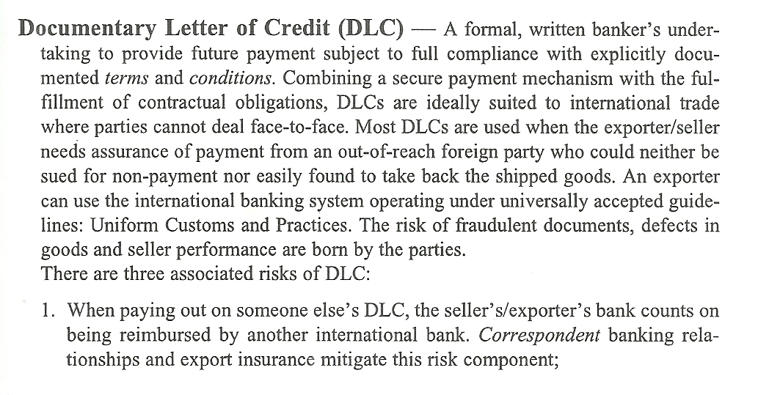
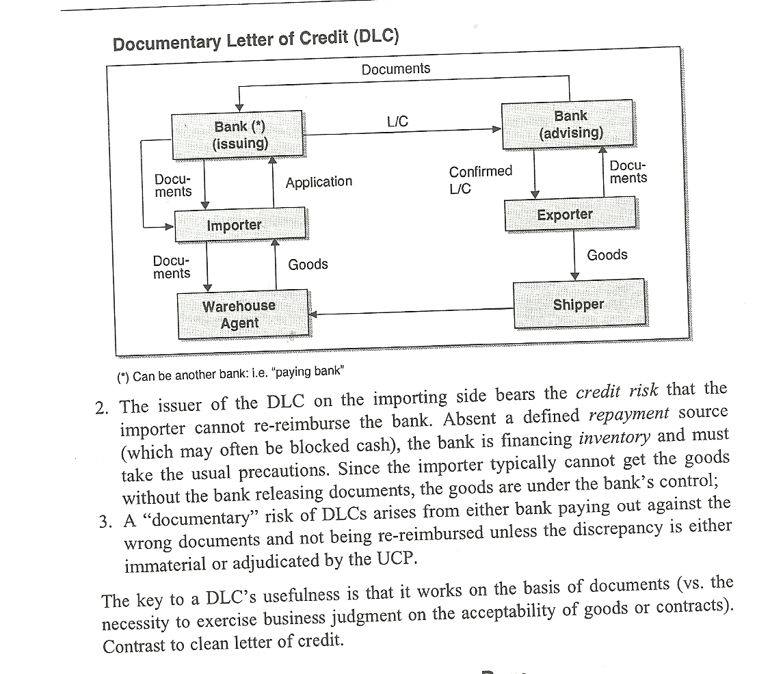

Sourced from: PwC A Compendium of Banking Terms by R. Patterson (1999: Business Press, Warszawa), p. 345, 346

Finally, this negotiation is an occasion for you to do a meaty case study. You will be helped a lot if you bring into your negotiation an array of visual aids – things to show, touch, fill in, support you with and discuss: colours, shapes, place names, geographical locations, names of documents etc. etc.

As a business format, a negotiation needs to structure – small talk, agenda to be agreed, individual agenda items to be covered, summary, handshakes etc.
All of the above must be nicely wrapped up with the language of negotiations.
Good Luck!

