Graphs and charts
Note the following.
1. a line graph (contains lines)
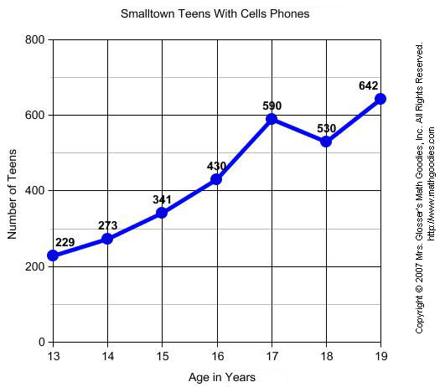

2. a bar chart (contains bars)
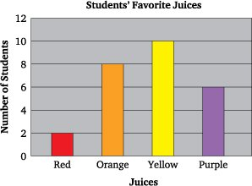

3. a pie chart (contains slices/segments/quadrants)

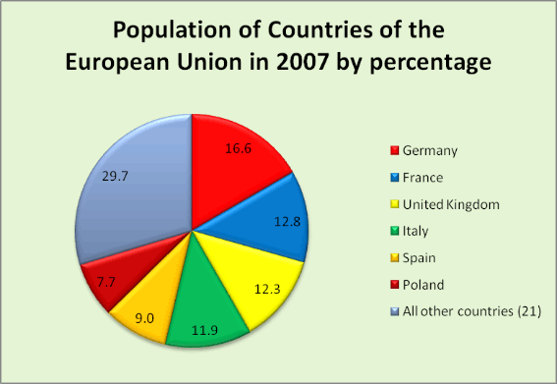

How do you describe charts and statistics?

This pie chart shows/presents ……..
One out of/in three EU citizens was German.
30% of EU citizens were German and nearly 8% of EU citizens were Polish.
While the Germans accounted for 16.6% of EU citizens, the Poles accounted for another 7.7%.

When we look at the pie chart below, we will see that ..

The below pie chart shows/presents the results of a survey conducted in 700 listed/quoted companies, which have merged with or acquired a company.
The blue slice shows that 17% of the deals created stockholder value, compared to 53% which reduced the value. By comparison, 30% of the deals neither created nor destroyed stockholder value. The grey segment accounts for these neutral deals.

