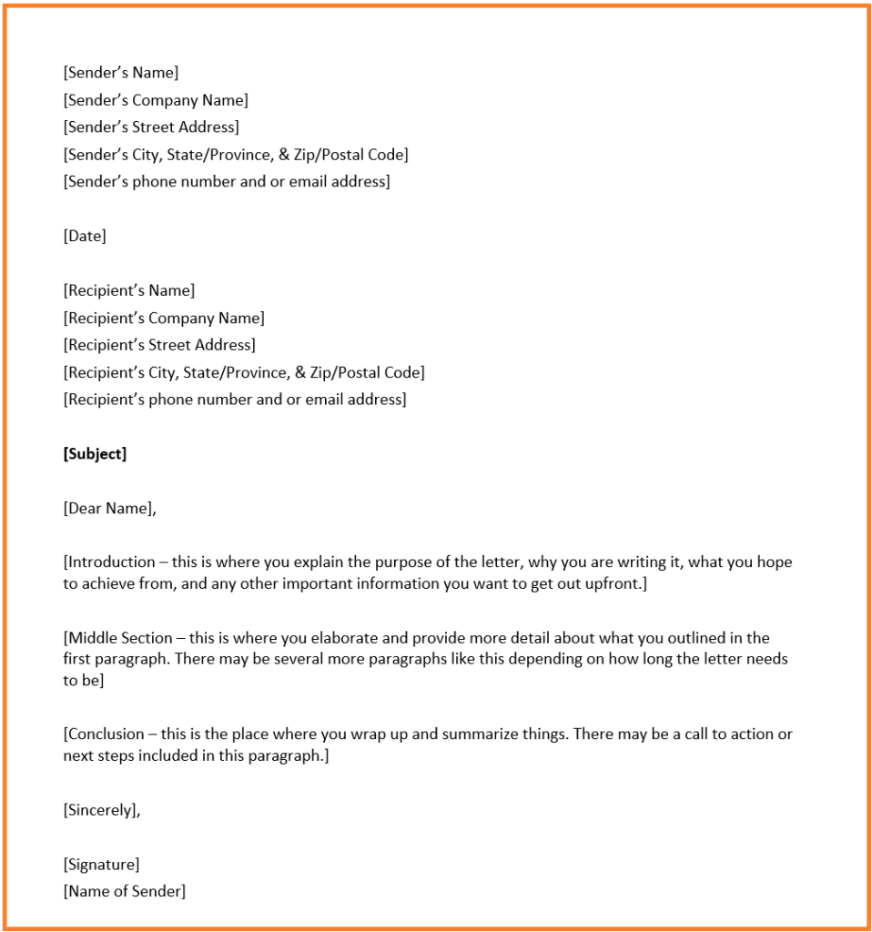

Source: https://corporatefinanceinstitute.com/resources/templates/transactions/business-letter-format/

